Deploying app with webpack

Create app:

* ng new your-app-name

Start the app:

* ng serve

Step:1 Let’s Put the App into the production

* ng build - -configuration=production

OR

* ng build (deprecated)

after running this code /dist folder will be prepared in your root directory

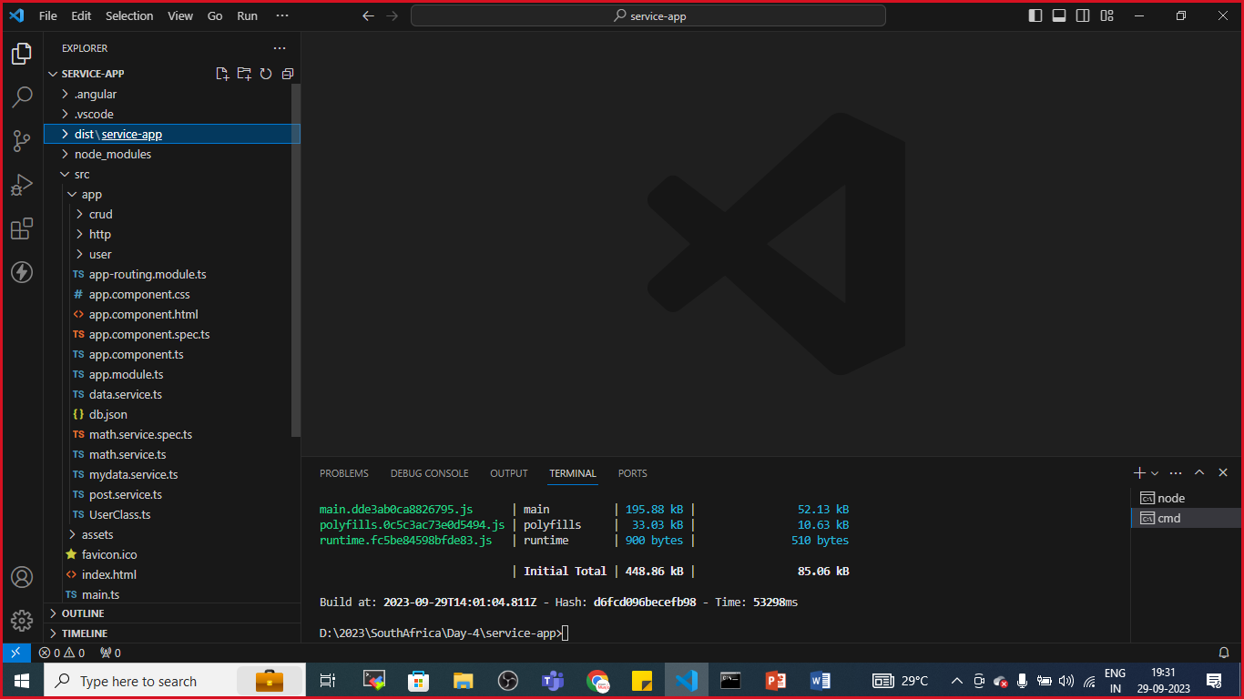

Step:2 create ‘webpack.config.js’ file

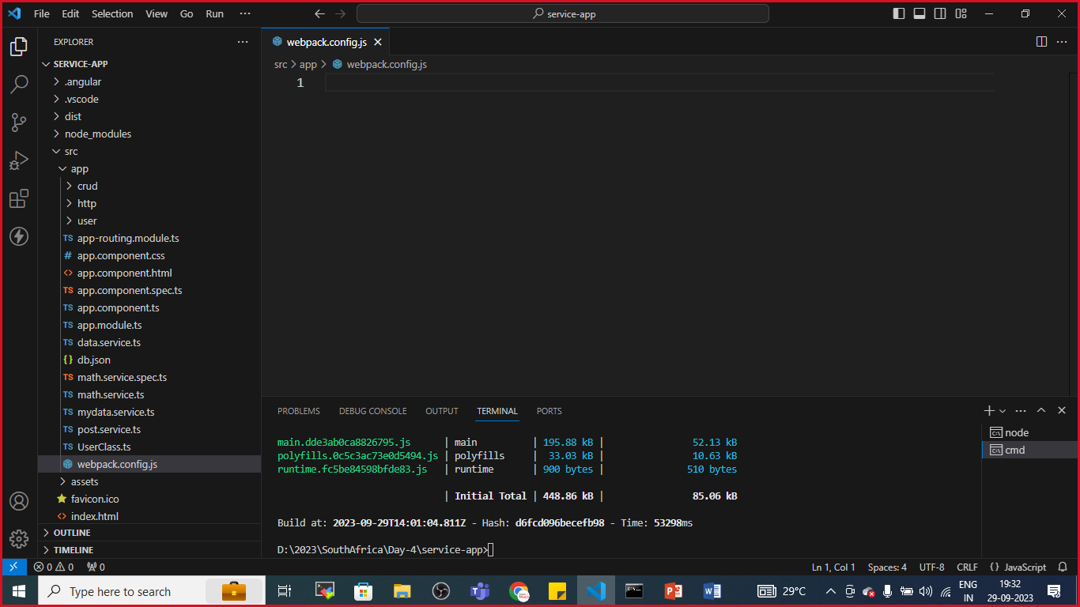

This file is used to extend the default webpack configuration

Step:3 Install custom webpack

* npm install @angular-builders/custom-webpack - - save-dev

step:4 goto angular.json file

search for architect

"architect": {

        "build": {

          "builder": "@angular-builder/custom-webpack:browser",

And update the builder As Mentioned Above

Update webpack.config.json file

const webpack=require('webpack');

module.exports={

    entry:'./src/index.js',

    output:{

        filename:'bundle.js',

        path:path.resolve(__dirname, 'dist'),

    },

};

Step:5 Build The App

* ng build --configuration=production

now All done But to check whether the app is ready to deploy on server or not

let’s install http server

Step:6 http server

* npm install –g http-server

After Successful installation

* cd >your-app-name
* http-server

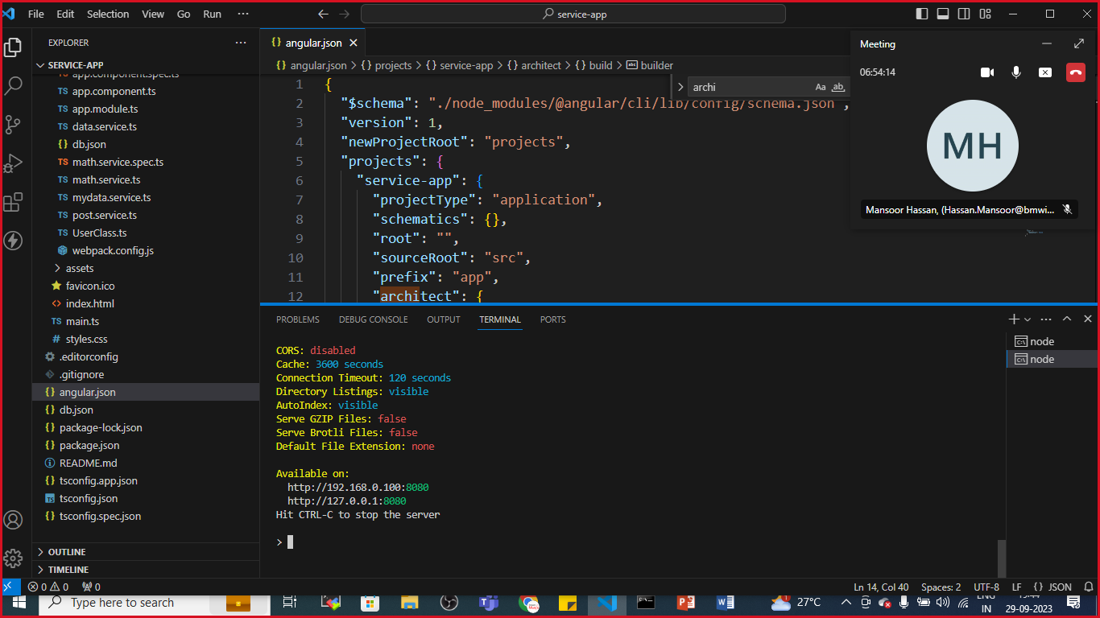

By default server is listening to port no:8080

Goto browser:localhost:8080

Live Server:

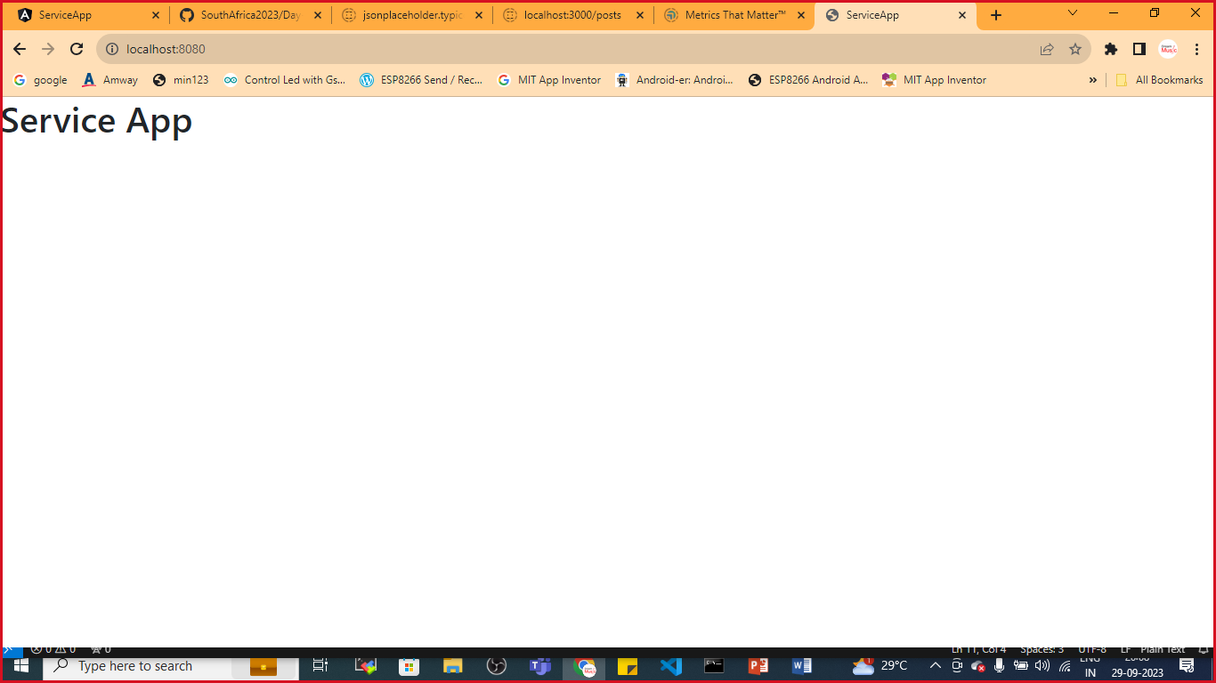

Local Server:

